1) | Each row in a table is referred to as a__________
2) | A record in one table that is related to a single record in a second table.
3) | __________________is similar in appearance to a spreadsheet, in that data is stored in rows and columns.
4) | A common function of this is to retrieve specific data from tables. Lets you add criteria to “filter” the data down to the records you want.
5) | Each record consists of one or more __________, which correspond to the columns in the table.
6) | A Connection between two tables based on a common field for the purpose of displaying or extracting information from connected records in both tables.
7) | ____________allow you to create a user interface in which you can enter and edit your data.
8) | A record in one table that may be related to many records in another table.
9) | ____________are what you use to format, summarize and present data. They usually answers a specific question.
10) | One table can be related to another table, which is generally referred to as performing a_________________.

Please label the parts of the Record Navigation Bar
12)
11)
13)

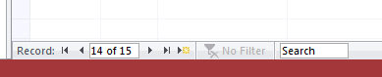
14)
15)
16)

