On any piece of paper, use the code below to write your name using uppercase and lowercase letters where appropriate.
Example: Sue Davis = 01010011,01110101,01100101 01000100,01100001,01110110,01101001,01110011
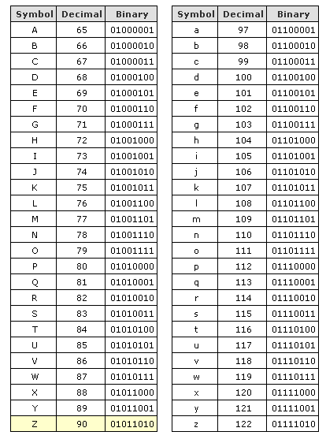
S u e D a v i s

