AFHS BUSINESS DEPARTMENT
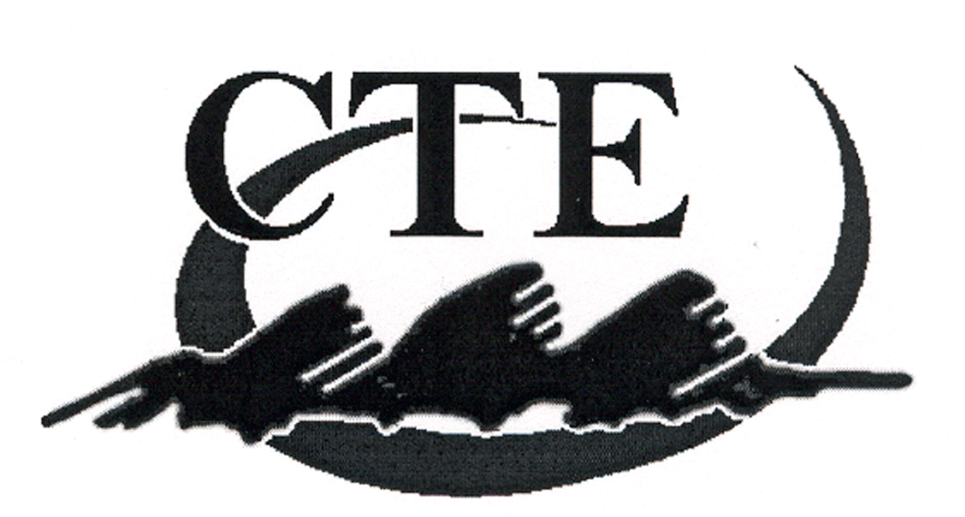
Classroom Policies

Career and Technical Education

- Absolutely NO candy or pop will be allowed in the classroom. If you bring it in the classroom, it will be thrown away.

- Your work area must be cleaned at the end of each class period. Please pick up all your papers. Vandalism or writing on desks, equipment, or any classroom items will not be tolerated. You will be fined for any damage that you cause and/or will clean the classroom for these activities.

- You are to be prepared each day with your textbook, assignments, notebook, pen, paper, and calculators (if required). You will NOT be allowed to go to your locker to retrieve these items.

- Assignments are due on the due date. One late pass per quarter will be given. If the late pass is not used, it can be turned in for extra credit at the end of the quarter. Other than the one use of a late pass, NO LATE ASSIGNMENTS WILL BE ACCEPTED!

- Quizzes and tests may be made up ½ hour before or after school. They must be completed in this time period. If you miss a test or quiz due to illness, you have one week from the date of the test or quiz to make it up. If you are absent the day before the exam or quiz, you are still required to take the exam on the scheduled date.

- All makeup work (NOT LATE WORK!) must be handed personally to the instructor in order to receive credit. Late pass with assignment stapled to it must be handed directly to the instructor. Makeup work and last pass work placed in the basket will receive NO credit.

- Class discussion and participation are greatly encouraged, but please respect the rights of others.

- Students are expected to follow class rules as given by the teacher. All students must sit in their assigned seat.

- Students are expected to respect the rights and personal property of the teacher and other students.

- The business computer room is open half-hour before and after school with the exception of when teachers are on school-related assignments. The lab closes at 2:45 p.m. on most days, and the network is shut down. If you wish to use the equipment, you must have prior approval from the instructor. The business lab is for business students only. Do not bring friends with you to the lab.

- For most business classes, students will be assigned a textbook that will be their responsibility to take care of properly and return to the bookcase at the end of each class period. Take precautions to avoid damaging your textbook.

- If you need to take a textbook home, there are textbooks available for checkout from the instructor.

- Extra credit will be given on a class-wide basis only.

- Absolutely NO cell phones or other electronic equipment will be allowed in Business Dept. classrooms. If you bring any equipment in, it will be confiscated.

- Students are expected to be honest and ethical in their conduct which includes following copyright laws.

- There is a NO tolerance rule in effect for cheating, If a student is caught cheating, he/she will receive a “0" for the assignment/quiz. This includes but is not limited to the following behaviors:
• copying another’s assignment/exam
• giving your work to other students
• printing duplicate copies of your work for others
• talking during tests/quizzes
• using notes during tests
• using technology dishonestly

Resources:
State Standards and Competencies: http://www.schools.utah.gov/ate/Skills/bus/250.htm
Computer Technology Curriculum Map:
http://sites.google.com/site/afhsbusiness

