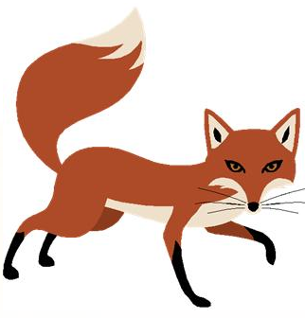
Keyboarding Drill #5
Instructions:
Retype each line in the space provided between lines.
Remember to use correct keyboarding postures and technique.
Insert a right-aligned header with your name and class period. (Insert, Header, Edit Header, Alignment Tab, Right)
Save the drill as keyboardingdrill5 to your student drive.
Do not print.
- Olga sews aqua and red silk to make six big kites. I am a man of his word and trust.

- I am to form a plan to buy a firm in the old town. Eight of the girls may go with them.

3. Corla is to work with us to fix the big dock sign. Keith is to pay the six men for working.

- Dodi is to go with the men to audit the six firms. Nigel saw a quick red fox jump high.

