Name: ________________________
Instructions: Label the parts of the Photoshop interface below. Then answer the questions that follow.

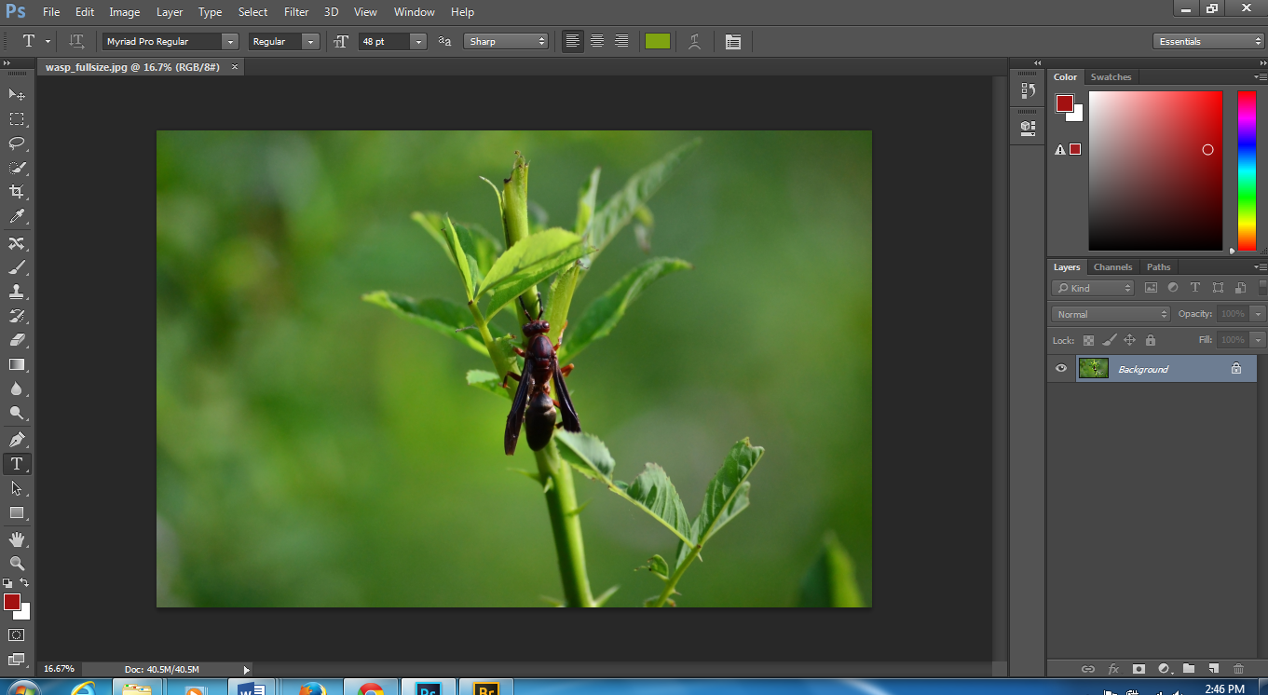

1. To open an image in Photoshop I would:____________________________________________________________________________
2. Photoshop documents are saved with a file extension of: _______________________________________________________________
3. Photoshop is image editing software created by: ______________________________________________________________________
4. When a Photoshop document is saved in the .psd format, what happens to the layers? ___________________________________________
5. When a Photoshop document is saved in a .jpeg format, what happens to the layers? ___________________________________________
6. How do you access the hidden tools in the Tools Panel? ___________________________________________________________________
7. What is displayed on the Options Bar in Photoshop? ______________________________________________________________________
8. Which panel allows you access your document’s history and undo changes? ___________________________________________________
9. Can you have more than one image open at a time in Photoshop? ___________________________________________________________
10. What do the following Windows Keyboard Shortcuts do in Photoshop:
CTRL + X ______________ CTRL + Z _______________ CTRL + C________________
CTRL + V ______________ CTRL + + _______________ CTRL + - ________________
CTRL + D ______________ CTRL + T _______________ CTRL + S ________________

