Web Design Review 3 Name:__________________

Using the Review 3 Power Point, answer each question, then record the correct answer.
*. What is the best thing I can do to prepare for the Competency Test?
My Choice: | A | B | C | D
The Answer: | Study Hard
- What does HTML stand for? |  |  |  |  |  | 4. Which attribute will give a background color of blue?
My Choice: | A | B | C | D |  | My Choice: |  |  | A | B | C | D
The Answer: | Hypertext Markup Language |  |  |  |  | The Answer: |  |  | style=”background-color:blue”
2. What the animated transformation of one image to another by a gradual distortion? |  |  |  |  |  | 5. What creates dynamic content such as rollovers and interactive forms?
My Choice: | A | B | C | D |  | My Choice: |  |  | A | B | C | D
The Answer: | Morphing |  |  |  |  | The Answer: |  |  | Java Script
3. What is the HTML code needed for  Web Design is the best |  |  |  |  |  | 6. What is this image?
My Choice: | A | B | C | D |  | My Choice: |  |  | A | B | C | D
The Answer: | <u> </u> |  |  |  |  | The Answer: |  |  | Thumbnail

7. Why type of fonts are Franklin, Grizzly, and Kabel? |  |  |  |  |  | 12. What is the abbreviation for Uniform Resource Locator?
My Choice: | A | B | C | D |  | My Choice: | A | B | C | D
The Answer: |  |  |  |  |  | The Answer:
8. What is the correct HTML tag to create an external link? |  |  |  |  |  | 13. What HTML tag adjusts the horizontal space around a graphic?
My Choice: | A | B | C | D |  | My Choice: | A | B | C | D
The Answer: |  |  |  |  |  | The Answer:
9. What is happening when a file is transferred from a computer to the internet? |  |  |  |  |  | 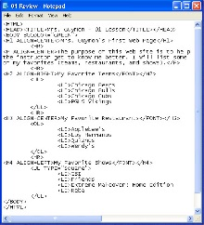  14. What is the first item in the numbered list?
My Choice: | A | B | C | D |  | My Choice: | A | B | C | D
The Answer: |  |  |  |  |  | The Answer:
10. What is purpose of the TCP/IP protocol? |  |  |  |  |  | 15. What kind of file is used with .png format
My Choice: | A | B | C | D |  | My Choice: | A | B | C | D
The Answer: |  |  |  |  |  | The Answer:
11. What does the abbreviation CSS stand for? |  |  |  |  |  | 16. Where in the HTML content are keywords and descriptions located?
My Choice: | A | B | C | D |  | My Choice: | A | B | C | D
The Answer: |  |  |  |  |  | The Answer:

17. What do users get a lot of when they have a free Internet Service Provider? |  |  |  |  |  | 22. What design principle is applied when all pages on a web site feel similar?
My Choice: | A | B | C | D |  | My Choice: | A | B | C | D
The Answer: |  |  |  |  |  | The Answer:
18. What would be the best use for this image? |  |  |  |  |  | 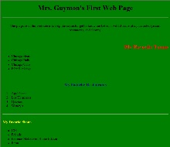  23. Where is the arrow pointing?
My Choice: | A | B | C | D |  | My Choice: | A | B | C | D
The Answer: |  |  |  |  |  | The Answer:
19. What font face is straight edged? |  |  |  |  |  | 24. What file of file has a .exe extension?
My Choice: | A | B | C | D |  | My Choice: | A | B | C | D
The Answer: |  |  |  |  |  | The Answer:
20. What is “www.uvu.edu”? |  |  |  |  |  | 25. What does the HTML tag <h3> create?
My Choice: | A | B | C | D |  | My Choice: | A | B | C | D
The Answer: |  |  |  |  |  | The Answer:
21. What is Adobe Dreamweaver? |  |  |  |  |  | 26. What filter is applied to this text? 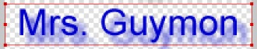
My Choice: | A | B | C | D |  | My Choice: | A | B | C | D
The Answer: |  |  |  |  |  | The Answer:

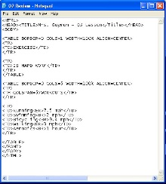  27. How many tables will be on this web page? |  |  |  |  |  | 32. Where is black the default color?
My Choice: | A | B | C | D |  | My Choice: | A | B | C | D
The Answer: |  |  |  |  |  | The Answer:
28. Which item shows only the Domain Name? |  |  |  |  |  | 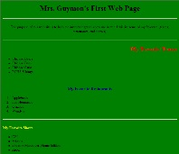  33. Where is the arrow pointing?
My Choice: | A | B | C | D |  | My Choice: | A | B | C | D
The Answer: |  |  |  |  |  | The Answer:
29. What HTML tag creates a heading cell in a table? |  |  |  |  |  | 34. What is happening when an image is changed from .png format to a .jpg format?
My Choice: | A | B | C | D |  | My Choice: | A | B | C | D
The Answer: |  |  |  |  |  | The Answer:
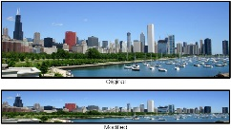  30. What is incorrect about the modified image? |  |  |  |  |  | 35. What is the difference between two or more elements on a page?
My Choice: | A | B | C | D |  | My Choice: | A | B | C | D
The Answer: |  |  |  |  |  | The Answer:
31. What allows users access to network resources, such as printing? |  |  |  |  |  | 36. What does the abbreviation AUP represent?
My Choice: | A | B | C | D |  | My Choice: | A | B | C | D
The Answer: |  |  |  |  |  | The Answer:

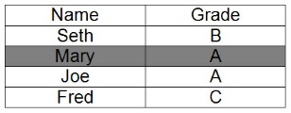  7. What is the highlighted part of this table? |  |  |  |  |  | 42. Which HTML tag is NOT a heading size?
My Choice: | A | B | C | D |  | My Choice: | A | B | C | D
The Answer: |  |  |  |  |  | The Answer:
38. What page is the index.html web page? |  |  |  |  |  | 43. How is a table heading cell different from a table data cell?
My Choice: | A | B | C | D |  | My Choice: | A | B | C | D
The Answer: |  |  |  |  |  | The Answer:
39. How many rows are in the second table? |  |  |  |  |  | 44. Which item shows as the web page title?
My Choice: | A | B | C | D |  | My Choice: | A | B | C | D
The Answer: |  |  |  |  |  | The Answer:
40. What design principle suggests that alternate text be included as part of the HTML tag for an image? |  |  |  |  |  | 45. Where is purple the default color?
My Choice: | A | B | C | D |  | My Choice: | A | B | C | D
The Answer: |  |  |  |  |  | The Answer:
41. What do web designers often use to help create page layout? |  |  |  |  |  | 46. What color system uses #000BBB, #FFF000, and #BBBFFF?
My Choice: | A | B | C | D |  | My Choice: | A | B | C | D
The Answer: |  |  |  |  |  | The Answer:

47. What kind of file has an extension of .zip? |  |  |  |  |  | 52. Where is blue the default color?
My Choice: | A | B | C | D |  | My Choice: | A | B | C | D
The Answer: |  |  |  |  |  | The Answer:
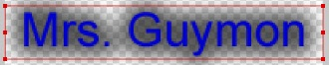  48. What filter is applied to this text? |  |  |  |  |  | 53. What is Notepad++?
My Choice: | A | B | C | D |  | My Choice: | A | B | C | D
The Answer: |  |  |  |  |  | The Answer:
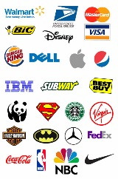  49. What does this image show? |  |  |  |  |  | 54. What HTML tag adjusts the vertical space around a graphic?
My Choice: | A | B | C | D |  | My Choice: | A | B | C | D
The Answer: |  |  |  |  |  | The Answer:
50. What is bandwidth used to measure? |  |  |  |  |  | 55. Where can an intranet be accessed?
My Choice: | A | B | C | D |  | My Choice: | A | B | C | D
The Answer: |  |  |  |  |  | The Answer:
51. What is the purpose of a thumbnail image? |  |  |  |  |  | 56. What is being used when a mouse points at a hyperlink and it changes color?
My Choice: | A | B | C | D |  | My Choice: | A | B | C | D
The Answer: |  |  |  |  |  | The Answer:

57. What are computers that are connected to create a massive worldwide network? |  |  |  |  |  | 62. What software can be downloaded, copied, and used without cost?
My Choice: | A | B | C | D |  | My Choice: | A | B | C | D
The Answer: |  |  |  |  |  | The Answer:
58. What does the abbreviation WAN represent? |  |  |  |  |  | 63. What is another name for hypermedia?
My Choice: | A | B | C | D |  | My Choice: | A | B | C | D
The Answer: |  |  |  |  |  | The Answer:
59. Which is NOT a domain extension used on the internet? |  |  |  |  |  | 64. What are .com, .edu, .org, .mil, and .net?
My Choice: | A | B | C | D |  | My Choice: | A | B | C | D
The Answer: |  |  |  |  |  | The Answer:
60. What are regular entries of commentary, events, and or other items? |  |  |  |  |  | 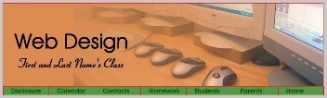  65. What is the name of this image?
My Choice: | A | B | C | D |  | My Choice: | A | B | C | D
The Answer: |  |  |  |  |  | The Answer:
61. What HTML tag creates an e-mail link? |  |  |  |  |  | 66. What is audience appeal?
My Choice: | A | B | C | D |  | My Choice: | A | B | C | D
The Answer: |  |  |  |  |  | The Answer:

67. What are two or more colors that blend together? |  |  |  |  |  | 72. What gets added to a web page with this HTML tag?  <img src=“friends.jpg” />
My Choice: | A | B | C | D |  | My Choice: | A | B | C | D
The Answer: |  |  |  |  |  | The Answer:
68. What are TCP/IP, HTTP, FTP, and Telnet? |  |  |  |  |  | 73. What is used by designers to control the look of a web site?
My Choice: | A | B | C | D |  | My Choice: | A | B | C | D
The Answer: |  |  |  |  |  | The Answer:
69. Which e-mail address is unique and useable? |  |  |  |  |  | 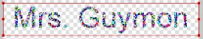  74. What filter is applied to this text?
My Choice: | A | B | C | D |  | My Choice: | A | B | C | D
The Answer: |  |  |  |  |  | The Answer:
70. What is happening when an internet file is transferred to a computer? |  |  |  |  |  | 75. Where is the arrow pointing?
My Choice: | A | B | C | D |  | My Choice: | A | B | C | D
The Answer: |  |  |  |  |  | The Answer:
71. What does the HTML tag <hr /> create? |  |  |  |  |  | 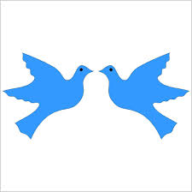  76. What design principle is shown in this image?
My Choice: | A | B | C | D |  | My Choice: | A | B | C | D
The Answer: |  |  |  |  |  | The Answer:

77. What type of fonts are Bodoni, Caslon, and Times New Roman? |  |  |  |  |  | 82. What font faces have lines or curves extending from the end of the letters?
My Choice: | A | B | C | D |  | My Choice: | A | B | C | D
The Answer: |  |  |  |  |  | The Answer:
78. What filter is applied to this text? |  |  |  |  |  | 83. How many columns are in the second table?
My Choice: | A | B | C | D |  | My Choice: | A | B | C | D
The Answer: |  |  |  |  |  | The Answer:
79. Where is the arrow pointing? |  |  |  |  |  | 84. What is happening when an .jpg image is opened or used in Adobe Fireworks?
My Choice: | A | B | C | D |  | My Choice: | A | B | C | D
The Answer: |  |  |  |  |  | The Answer:
80. What is an area of text or graphic that contains a hyperlink? |  |  |  |  |  | 85. What does 204.112.102.145 represent?
My Choice: | A | B | C | D |  | My Choice: | A | B | C | D
The Answer: |  |  |  |  |  | The Answer:
81. What gives an owner the right to publish and sell creative works? |  |  |  |  |  | 86. Where is white the default color?
My Choice: | A | B | C | D |  | My Choice: | A | B | C | D
The Answer: |  |  |  |  |  | The Answer:

87. What is the correct HTML tag to create an internal link? |  |  |  |  |  | 92. What does the abbreviation ISP represent?
My Choice: | A | B | C | D |  | My Choice: | A | B | C | D
The Answer: |  |  |  |  |  | The Answer:
88. What does this HTML tag create?  <p>Web Design is the best.</p> |  |  |  |  |  | 93. Which file is NOT used for graphics?
My Choice: | A | B | C | D |  | My Choice: | A | B | C | D
The Answer: |  |  |  |  |  | The Answer:
89. Which item is an example of a search engine? |  |  |  |  |  | 94. What is the repeated pattern of elements that create a sense of movement?
My Choice: | A | B | C | D |  | My Choice: | A | B | C | D
The Answer: |  |  |  |  |  | The Answer:
90. What does the abbreviation LAN represent? |  |  |  |  |  | 95. Which item will show up in the square bulleted list?
My Choice: | A | B | C | D |  | My Choice: | A | B | C | D
The Answer: |  |  |  |  |  | The Answer:
91. What is allowed after agreeing to a company’s network AUP? |  |  |  |  |  | 96. What does the abbreviation HTTP represent?
My Choice: | A | B | C | D |  | My Choice: | A | B | C | D
The Answer: |  |  |  |  |  | The Answer:
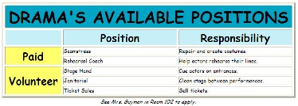  97. What HTML tag was used in the first row to make one big header cell? |  |  |  |  |  | 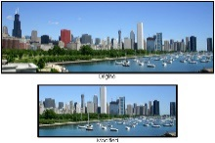  99. What was done to the modified image?
My Choice: | A | B | C | D |  | My Choice: | A | B | C | D
The Answer: |  |  |  |  |  | The Answer:
98. What kind of file has a .txt extension? |  |  |  |  |  | 100. Which item is NOT a web browser?
My Choice: | A | B | C | D |  | My Choice: | A | B | C | D
The Answer: |  |  |  |  |  | The Answer:

Total Questions | 100
# of Questions Missed | -
# of Questions Correct

